Contents
Abstract 2
Introduction 3
Objectives of the Study and Business Case 3
Literature Review 3
Methodology 6
Data Exploration 6
Experiment 8
Results 11
Discussion 22
Conclusion 23
Recommendations 24
Ethical Considerations and Limitations 24
References 25
Appendix 27

Abstract
This study examines the patterns and variables affecting automobile prices in the Australian market using a dataset that was gathered from multiple internet sources and included over 16,000 variables for the year 2023. Through the use of data visualisation techniques, the study examines trends from 1980 to 2020 and finds that there was an increase in prices between 2010 and 2020. After looking at the relationships between automobile brands, categories, and transmission types in more detail, the analysis concludes that SUVs are the most common car type and Toyota is the most popular brand.
The study divides cars into three groups: demo, freshly produced, and used. It shows that the latter two categories have significantly increased since 2010, which may be due to developments in technology. The prevalence of front-wheel drive and automatic transmission, together with the preference for unleaded petrol, are significant findings. An examination of exterior colour shows a preference for white vehicles. The dataset is subject to ethical consideration, which are acknowledged. Finally, the research offers valuable suggestions for businesses, car users, investors and the government.

Introduction
One of the favorite and simplest mode of transportation in Australia is cars. Cars are produced in millions and sold at different prices in Australia, despite their health hazards its pose to the environment. Despite the increase in the price of cars, commuter prefer to travel by car than other means of transportation around the city (Kent, 2014). Despite policies aimed at reducing the use of cars by applying technology, increased ownership and increased price, the use of cars have geometrically increased because cars provides ease of movement, access to more and distant destinations than public transport (Hiscock et al., 2002).
The Australian automotive industry turns Australia’s raw materials of aluminium and steel into highly value-added goods that are exported to the world. The industry sits proudly at the forefront of the domestic manufacturing industry as one of the leading contributors to the economy and the community. While Australia boast of different models of cars, it unique automobile market to serve its populace with increasing demand. The complex nature of car pricing in Australia ranges from the brand, body type, seats, the car type, car transmission, drive type, and other factors that car users engaged before buying a car. To this end, the study will examined the Australian car prices by using data-driven insights to access factors affecting the prices of cars in Australia.

Objectives of the Study and Business Case
The aim of the study is aimed at examining the factors affecting the prices of cars in Australia. The objectives of the study is to
- Identify the different patterns and trends in the prices of car from 1980 to 2010.
- apply visual representations to determine the factors affecting the prices of cars in Australia
- Identify the most potent characteristics affecting the prices of cars with respect to the different brands, models, and locations using visualisation.

Literature Review
Automobile plays an important role in the day to day living of people. It is used of transportation of goods and persons from one point to another. The car is a highly advanced technological device whose emissions pose a global health risk to people, animals, and plants (Salami, 2007). According to Donald (2007), an automobile is any self-propelled vehicle utilised for land-based transportation of persons and products.
The components of a car is divided into two major parts- the body and the chassis. The body is an area in the car where passengers and the driver have their seats while in some vehicle, it is an area where the goods (light or heavy weight cargos) are carried. On the other hand, the chassis is the engine room of the car. It is made up of components without which the car cannot function. Hillier and Rogers (2007) listed the components of a chassis to be the frame, wheels, axles, engine, steering, fuel tank and radiator.
Aside from the carriage of goods, cars provide comfort and mobility for families individuals, and businesses. However, the use and demand for automobile, especially luxury is tied to the price and other factors such as income, fuel prices and demand for substitute. A look at the supply factor affecting the prices of cars include the material and cost of chassis, and government policies. The automotive industry is experiencing an intense rivalry amongst competitors. This competition is a factor of the cost of the car, model fashion and style, and diversity. Hence, effective pricing model is sacrosanct for businesses focusing on manufacturing automobiles (Wang & Yang, 2016). Other factors that car manufacturers looked at is the market share for cars, competitive advantage of the business (Wang & Yang, 2016). On one hand, the increase in the number of models will decrease the production cost due to the existence of economy of scope, leading to the decrease in the price level. On the other hand, it will captures more variety effect since the consumers also prefers more choice, resulting in the increase in price (Wang & Yang, 2016).
In Australia, the cost of buying a new car can be quite expensive when compare with the minimum wages and the disposable income available to individuals, and households. Thus, used cars are preferred, purchases, and used. The majority of buyers and sellers of automobiles, however, are doubtful about the requirements to purchase or list a used vehicle. Of course, the appearance of a car is the first thing that draws a buyer in, but there are other characteristics that matter to someone who is either an expert in cars or does not know much about them (Beer, 2018). Also, the number of entrants into car production was significant, and included brands such as Volkswagen, British Motors Leyland and Nissan, alongside more recent participants in the industry (Beer, 2018). Since the demand for cars is in the increase these days, manufacturers of cars are proactively looking for opportunity, and conditions that will make consumers have value for their money by churning out cars in line with the safety, usability, and performance efficiency. By doing this, they can boost consumer loyalty to their brands by being innovative and differentiating themselves from the competition (Shahzaib & Emadul, 2021).
Several researchers have studied how buyers choose their automobiles, the study found out that the purchase of cars is a function of personal needs, convenience, comfort, car manufacturer, model of the car, and external factors such as satisfaction of the car, customer friendly, income (Menon & Raj, 2013; Vidyarthi, 2012; Srivastava & Tiwari, 2011). On the factors influencing consumer purchase intentions in buying Honda City in Karachi, Pakistan. Shahzaib & Emadul (2021) examined the compounding effect on consumer’s intention to buy Honda City with respect to alternative brands of car. Seven variables that would likely affect the consumer use of Honda City as identified in the study are brand loyalty, fuel efficiency, aesthetics, after sale service, attitude of the consumer, social prestige, and pricing. The result revealed that branding helps to build innovations and provides competitive edge for the customers. Vikram (2014) studied the most important factors affecting sales and demand for car. The result revealed that pricing and fuel efficiency were the most important factors in consumer purchasing behaviour, while advancements in technology and the performance and were the least important factors for the consumers. In the same vein, Rana & Lokhande (2015), studied the feedback of consumers’ who purchased certain brand of cars. The findings revealed that fuel efficiency, durability, and ability to repair, after sale services, and pricing the feedback of consumers.
Lee & Govindan (2014) studied emerging issues in car purchasing decision. They study centred on the determinant of consumers buying behaviour towards national cars in Kuala Lumpur with respect to the rapid growth in car ownership. Findings from the study revealed that the three independent variables of car’s reliability, safety, and price significantly influence consumer buying behaviour towards national cars in Kuala Lumpur. The research indicate that the concept of the study was dependent on the feedback of the consumers in that city which was related to fuel efficiency, durability and repair ability, after sale services, pricing overview and source of information used before considering the purchase of the vehicle (Rana & Lokhande, 2015). On the other hand, Alper & Mumcu (2007) performed analysis on the demand for new cars by adopting quarterly data on price, quantity, quality, country of origin, and product characteristics of the new automobile sales market demand during the period 1996-1999. The study revealed that the demand for new car showed a shortfall in the prices of cars from 1996-1999.

Methodology
The methodology explained the processes, and the steps adopted in running the analysis. It explained in details the data exploration, manipulation and the distribution patterns embedded in the dataset. In the study, visualisation techniques was used in finding answers to the research questions, thereby finding solutions to the Australian cars market.

Data Exploration
This section explored the dataset by summarising, identifying patters, and understanding the structure of the data to gain valuable insights and to answer the research questions. More so, an overall examination of the data will be carried out in this section.
The dataset
The dataset is the most recent statistics on price of Australian car for 2023. The purpose of the dataset is to determine the trends and factors affecting the prices of cars in the Australia. The variables in the dataset contains the various brands, models, types, title features of cars, car/SUV, used/new cars. Other are the transmission, engine, drive type, fuel type, fuel consumption, kilometres, colour (exterior/interior), location, cylinders in engine, body type, doors, seats, and price of cars sold in the Australian market. The data can be found on Kaggle via https://www.kaggle.com/datasets/nelgiriyewithana/australian-vehicle-prices/data.

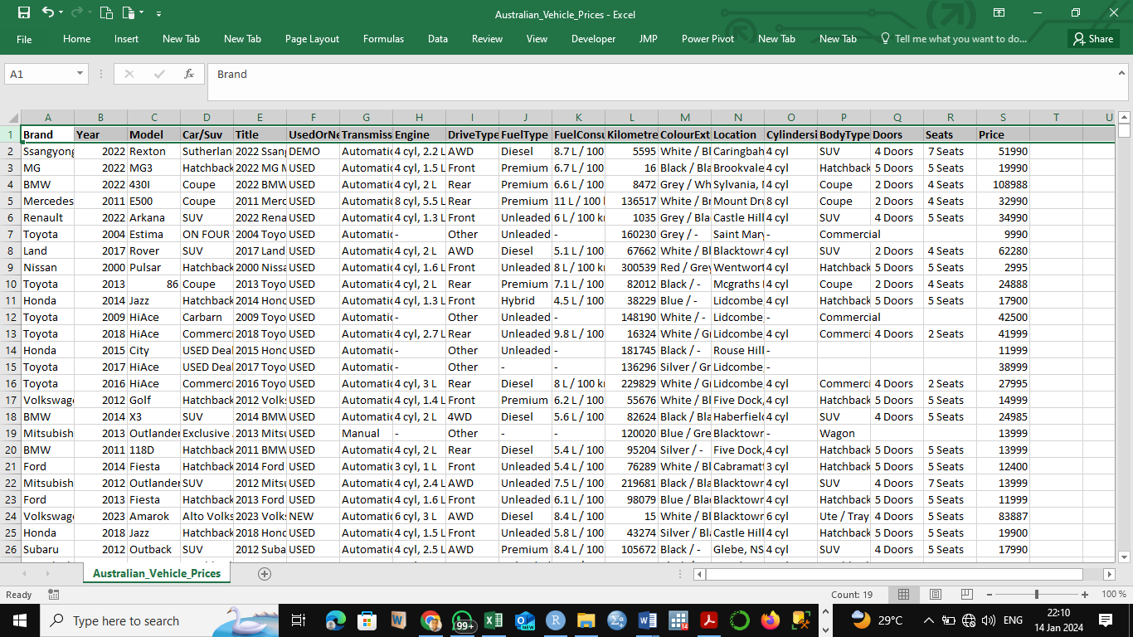
Figure 1: The Australian Car Data
Over 16,000 records of car listings from various Australian internet platforms are included in the dataset. The Australian Car Prices dataset is summarised in the table below:
Number of Variables | Variables with characters or strings | Variables with double
19 variables in the dataset | 17 variables are string/ character. e.g.  Brand, Model, Car/SUV, Title, Transmission, Engine, Drive Type, Fuel Consumption, etc. | 2 are double (numeric) e.g. Year and Prices
Table 1: The summary of Australian Car Prices Dataset
Data Importation
To import the data into the R studio interface, the codes below were used:
library(readr)
Australian_Vehicle_Prices <- read_csv("C:/Users/PROGRESSIVE/Desktop/UFUOMA/R Folder/Australian_Vehicle_Prices.csv")
head (Australian_Vehicle_Prices)

# A tibble: 6 × 19
Brand Year Model `Car/Suv` Title UsedOrNew Transmission Engine DriveType FuelType
<chr> <dbl> <chr> <chr> <chr> <chr> <chr> <chr> <chr> <chr>
1 Ssan… 2022 Rext… Sutherla… 2022… DEMO Automatic 4 cyl… AWD Diesel
2 MG 2022 MG3 Hatchback 2022… USED Automatic 4 cyl… Front Premium
3 BMW 2022 430I Coupe 2022… USED Automatic 4 cyl… Rear Premium
4 Merc… 2011 E500 Coupe 2011… USED Automatic 8 cyl… Rear Premium
5 Rena… 2022 Arka… SUV 2022… USED Automatic 4 cyl… Front Unleaded
6 Toyo… 2004 Esti… ON FOUR … 2004… USED Automatic - Other Unleaded
# ℹ 9 more variables: FuelConsumption <chr>, Kilometres <chr>, ColourExtInt <chr>,
# Location <chr>, CylindersinEngine <chr>, BodyType <chr>, Doors <chr>,
# Seats <chr>, Price <dbl>

Experiment
Data Cleaning
In data cleaning, missing data, outliers and irregularites in the datasets will be addressed. To check for missing value, the syntax is.na(Australian_Vehicle_Prices) was used. The figure below showed that the Australian Vehicle Prices have a sizeable amount of missing values which could impact the quality of the analysis.
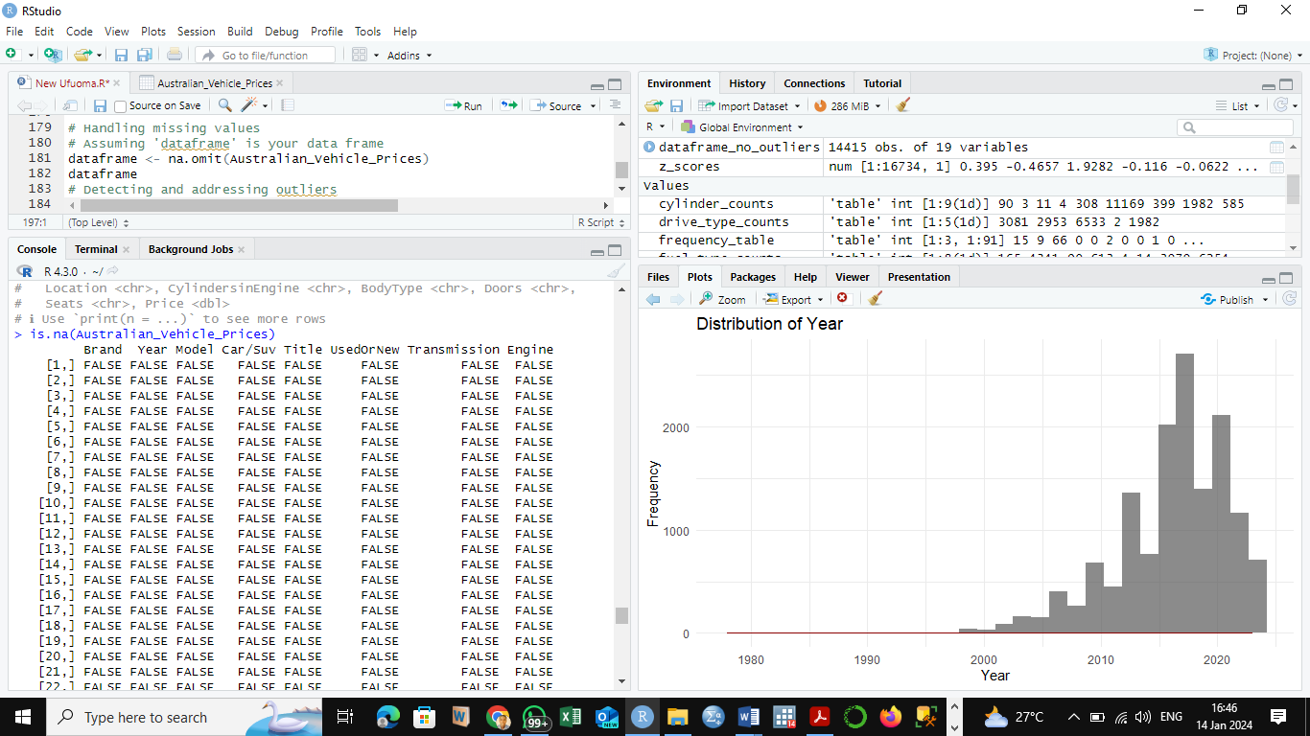
Fig 2: Presence of Missing Data in the Australian Dataset
To check the number of missing value, the syntax sum(is.na(Australian_Vehicle_Prices)) was used. In the dataset, there were 4105 missing data. To eliminate missing data, record elimination method was used. Hence, the syntax Australia <- na.omit(Australian_Vehicle_Prices) was used. This created another data frame called Australian. The dimension of the original data was checked using the syntax dim(Australian_Vehicle_Prices). Using this displayed the original data with 19 rows and 16734 columns. Also, the dimension of the cleaned data is checked using dim(Australian). Doing this, the dimension of the cleaned dataset was 19 rows and 14551 columns. To remove the outliers and anomalies in the newly created dataset, the syntax Australian <- Australian[!apply(Australian, 1, function(row) any(grepl("_", row))), , drop = FALSE]
Data Distribution Analysis
In the dataset, 17 variables are character while only 2 variable- Year and Prices are numeric. A proper examination of the distribution in the newly created dataset and its variables to determine its skewness and normal distribution patterns are showed below (See Appendix for the Syntax).
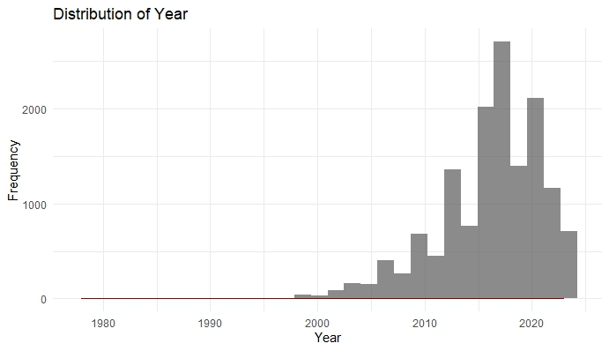
Fig 3: Historgram Showing the Distribution of the Year Data

The histogram revealed that the year in which the cars are sold. Since the year is a numeric data, the Australian dataset majority of the cars are sold ffrom year 2010 to 2020. The year variable is skewed to the right, implying that more cars are sold in year 2010 to 2020 than the previous years.

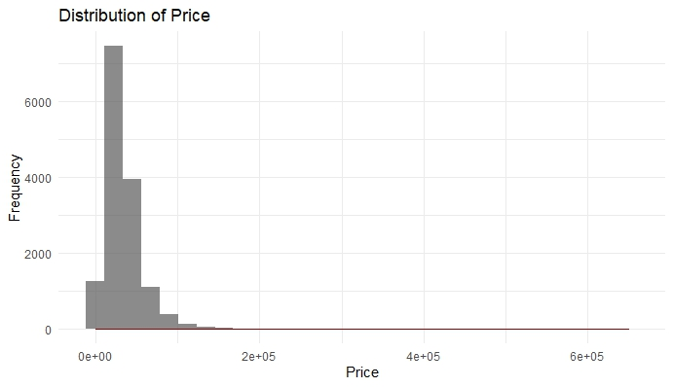
Fig 4: Historgram Showing the Distribution of Price
The histogram revealed the price in which the cars are sold. The Australian dataset showed that more cars are sold for less than 20, 000 Australian dollars. Likewise, the price variable is skewed to the left. This comfirmed that majority of the cars are used cars and are sold for less than th acquire price in which a newly manufactured care would have been sold.

Results
Objective 1: Identify the different patterns and trends in the prices of car from 1980 to 2010
Figure 5 showed the prices of Australian cars for five decades. The result revealed that the prices of used, manufactured and demo cars increased and surged for two decades- 2010 and 2020. However, the drop in the prices of cars stared from 1900 and surged in 2000 (See Appendix for the Syntax).
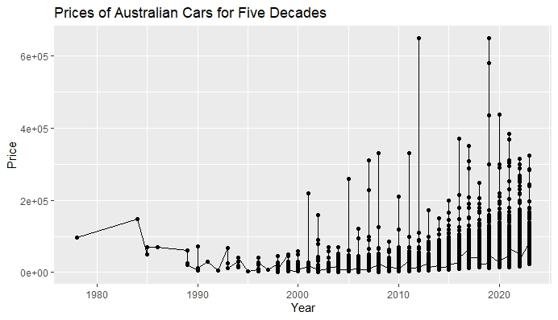
Figure 5: Prices of Australian Cars for Five Decades
When examined the relationship between the car brands and the year in which the car was sold, result from figure 6 below revealed that before the 1990’s, Holden and Mitsubishi were the reigning car brands than other brands in the top ten. On the other hand, Toyata, Volkswagen, Nissan were mostly used from 2000 to 2020. (See Appendix for the Syntax).
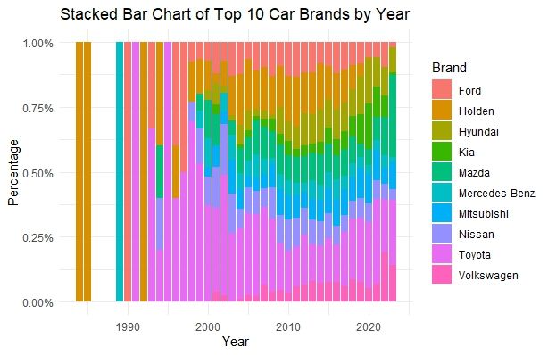
Fig 6: The Relationship between Car Brands and the Year Sold in the Australian Market

From 1980 to 2020, fairly used cars were mostly used in Australia. Newly manufactured and demo cars were mostly used in 2020 in Australia. This demonstrated that the newly manufactured and demo car are either electric cars or hybrid mode while the used car or diesel or cars powered by gas. Likewise, changes in technology, is a major factor contributing the use of manufactured and demo cars in Australia (See Appendix for the Syntax).
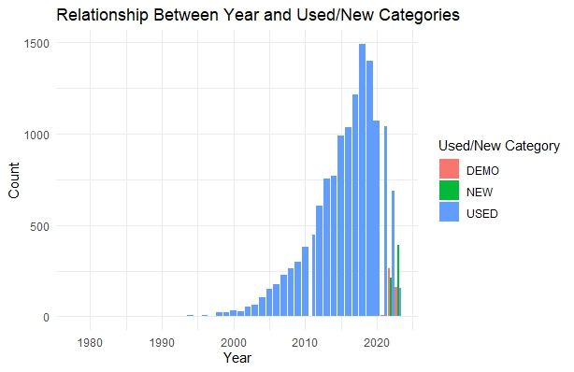
Fig 7: The Relationship between Year and Car Categories in Australia
Examining the relationship between car categories and the year the car was sold, fig 8 revealed that the peak year in which all cars was used, manufactured or used as demo was from year 2010 to 2020. From year 2010 to 2020, more than 10,000 cars were used, manufactured, and demonstrated in Australia (See Appendix for the Syntax).
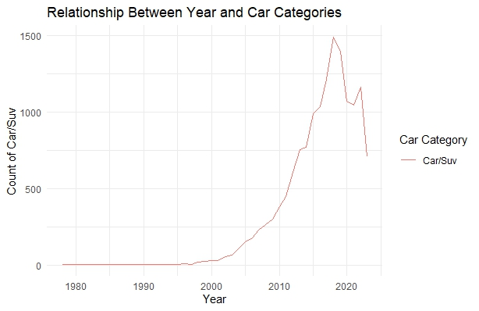
Fig 8: The Relationship between Year and Car Categories in Australia

Objective 2: To apply visual representations to determine the factors affecting the prices of cars in Australia
Figure 9 revealed the top 10 car brands sold in the Australian car market. Among the different brand cars sold in the Australia, Toyota consituted more than 21% of the car used and sold in the Australia, followed by Hyundai 11.1%, Mazda 10.3%, Holden 9.9%. Among the tope ten car brands, Mercedes Benz was used less than any other car brands among the top ten car brands (See Appendix for the Syntax).

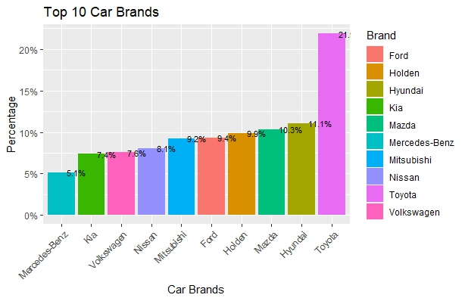
Fig 9: The Distribution of Car Brands Sold in the Australian Market
Fig 6 showed the top ten car types used in Australia. Of the top ten used car types in Australia, approximately 44% are SUV, hatchback (17.42%), Ute/Tray (15.3%), Sedan (14%). Also, Wagon (4.16%), Commercial (2.25%), Coupe was approximately 2%, Convertible (0.74%), Rockdale Mazda New (0.31%), and Alto Blacktown (0.27%). Majority of the used car types is the SUV (See Appendix for the Syntax).
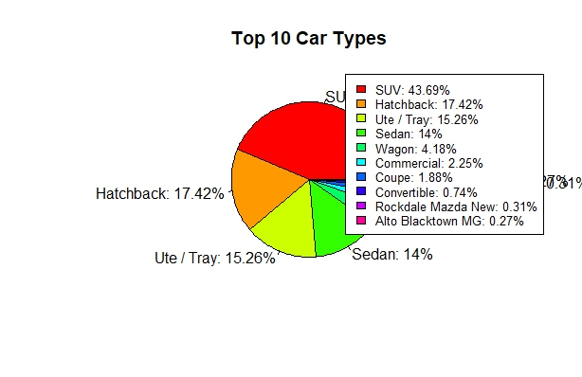
Fig 10: The Distribution Top 10 Car Type Used in Australia
Fig 11 revealed the categories of cars sold in Australia. Of the total cars sold in Australian car market from 1980 to 2020, approximately 93% are used cars, 4% are newly manufactured car and 3% are demo cars. This used that cars majorly used and sold in Australia are used (See Appendix for the Syntax).
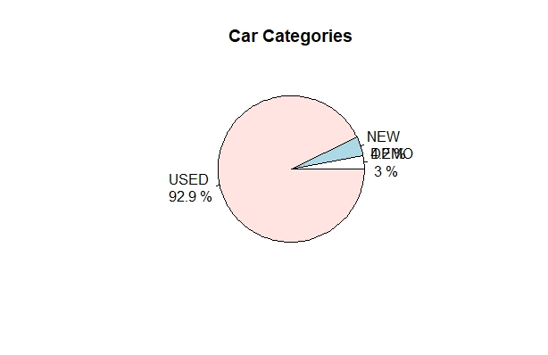
Fig 11: The Distribution Categories of Cars used in Australia

Objective 3: Identify the most potent characteristics affecting the prices of cars with respect to the different brands, models, and locations using visualisation.
Figure 12 showed the distribution of cars used, manufactured or demo in Australia based on the transmission type of the cars. From the result, majority of the cars used, manufactured or demo made used of automatic transmission system (88%) while 12% of the cars have manual transmission system (See Appendix for the Syntax).
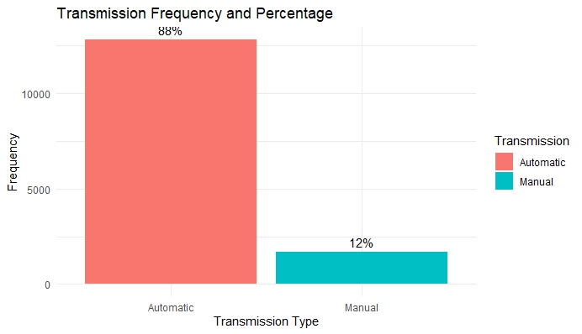
Fig 12: The Distribution of Cars in Australia Based on the Transmission Type
Figure 12 revealed the distribution of cars used, manufactured or demo in Australia based on the drive type of the cars. From the result, approximately 45% of cars used, manufactured or demo made used of the front drive type, 21.2% are 4WD, 13.6% USED the rear drive type, 20.2% of the cars are All-Wheel drive, and less than 1 percent of the cars belong to other categories of car drive type (See Appendix for the Syntax).

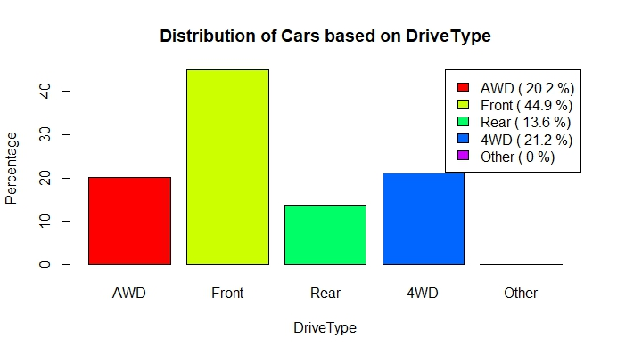
Fig 13: The Distribution of Cars in Australia Based on Drive Type
Results from figure 14 showed the distribution of Australian cars based on the fuel type. Of all the cars, majority of the cars used are the unleaded. That is most of the cars are used with gas without any lead in it. In addition, 30.23% of the car used the diesel, 21.3% premium motor spirit, 4.2% of cars used in Australia are hybrid car such that the cars used but diesel and electric effectively and efficiently (See Appendix for the Syntax).
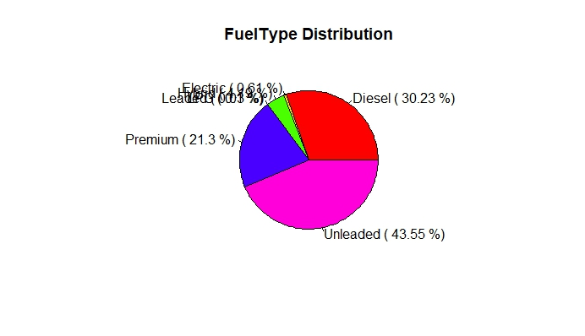
Fig 14: The Distribution of Cars in Australia Based on Fuel Type
Figure 15 showed the exterior and interior of the car used in Australia. Majority of the top exterior of the cars used in Australia have the white (See Appendix for the Syntax).
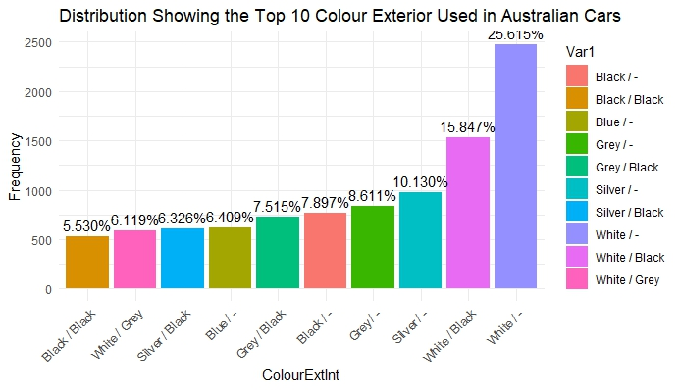
Fig 15: The Distribution of Cars Showing the Top 10 Colour Exterior Used in Australia
Figure 16 revealed the number of cylinders embedded in the used, manufactured and demo car in the Australian market. Majority of the cars used in Australia are 4 cylindrical cars, followed by 6 cylindrical cars (13.6%), 8 cylindrical cars (4.02%). However, less than one percent of the cars used and manufactured have 2 cylinders (See Appendix for the Syntax).
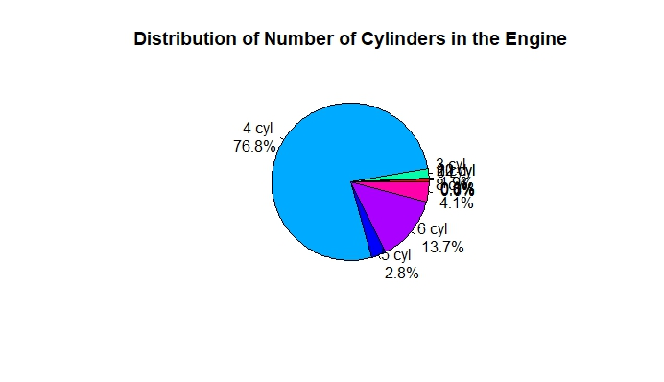
Figure 16: Distribution of Cars Based on the Number of Cylinders in the Engine

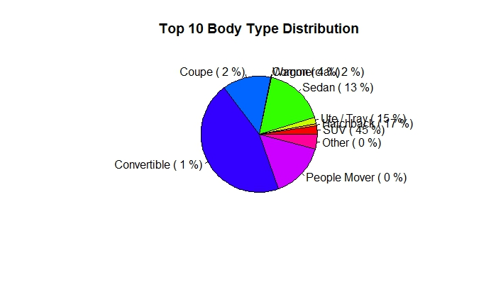
Figure 17: Distribution of Cars Based on the Body Type
Figure 17 showed the distribution of Australian cars based on the body type of the car. The result revealed that less than one percent of the cars used in Australia are people mover, while some has other body types. On the other hand, majority of the cars used in Australia are the SUV body type (45.2%), 16.9% have the Hatchback body type, and 13.4% have the Sedan body type (See Appendix for the Syntax).

Discussion
The dataset offers a chance to investigate regional differences in car preferences and costs. In recognising the trends in the prices of cars from 1980 to 2010. The analysis of automobile pricing over the course of 50 years revealed a notable rise in prices between 1980 and 2020, with a peak observed in the 2010s. This is consistent with the worldwide trend of rising car prices. The association between automobile brands and the year of sale revealed changes in consumer preference, with Toyota leading the way in recent times. There was a noticeable desire for used cars, as evidenced by the rise in produced and demo vehicles in 2020, which may have been caused by technological breakthroughs and environmental concerns.
With approximately 21% of the cars in the dataset, Toyota was the most prevalent brand according to the distribution of car brands. SUVs were the most popular car category, accounting for almost 44% of sales. Used vehicles made up the majority of sales, indicating a desire for affordability. Comparably, the examination of transmission types showed that 88% of respondents favoured automatic transmissions, while the distribution according to drive type showed that 45% of respondents preferred front-wheel drive. White was the most popular exterior hue, and unleaded fuel was used the most frequently (45.2%).
Additionally, the research showed that a number of categorical factors, including gasoline type, drive type, and transmission type, had significant influences on car pricing. Front-wheel drive, automatic transmissions, and unleaded gasoline-powered vehicles appear to be consumer preferences. This implies that these characteristics influence the producers' pricing policies. To this end, the results aligned with Menon & Raj (2013); Vidyarthi (2012). Furthermore, analysing the dataset across several decades sheds light on how the automobile sector has changed over time. A number of variables, such as inflation, changes in customer preferences, and technical improvements, can be blamed for the price explosion that occurred between 1980 and 2020. The findings agreed with (Rana & Lokhande, 2015; Alper & Mumcu, 2007). A move towards more sophisticated, eco-friendly technologies may be seen by the rise in manufactured and demo vehicles in recent years. Conversely, Toyota's dominance in the dataset points to a strong brand presence and perhaps significant levels of customer loyalty. In order to shape the future of the automotive industry, manufacturers and policymakers must have a thorough understanding of customer preferences and brand dynamics. Furthermore, the popularity of SUVs and the uptake of electric and hybrid vehicles are indicators of a rising consciousness regarding environmental issues. Future insights into the sector may be gained by examining how customer preferences, governmental regulations, and environmental consciousness interact.

Conclusion
In conclusion, the examination of the Australian automobile prices dataset offers significant perspectives on the workings of the automotive industry. Major trends are shown by the visualisations, including price increases over the past few decades, with a major uptick from 2010 to 2020. SUVs are common, some automobile manufacturers are dominant, and automatic transmissions are becoming more and more common. These are some of the important factors impacting consumer decisions. The results highlight how crucial it is to take into account variables like preferred brands, vehicle types, and transmission systems when analysing pricing trends. With an increasing focus on sustainability and technology improvements, the automotive industry is evolving. These insights help to provide a full picture of the Australian vehicle market. Subsequent investigations may explore the impact of price fluctuations. Although, the analysis do not consider the qualitative factors of pricing, hence other customer preferences, motivations, should be considered.

Recommendations
- Companies in the automobile industry could use the price and preference trends for cars for marketing and segmentation plans.
- Investments in eco-friendly projects and incentives for electric or hybrid vehicles can complement the growing consumer interest in making environmentally friendly cars.
- Businesses in Australia should emphasise the long-term advantages and economic viability of hybrid and electric vehicles.
- Other features that affecting the demand of cars such like customer behaviour, market trends, and economic factors should be addressed.

Ethical Considerations and Limitations
Ethical considerations dominated the analysis of the Australian automobile market. Because the dataset was gathered from online sites and contains personal information about people who have posted information about their cars. Hence, privacy concerns are raised by its use. Personal information of the buyers are anonymizing and aggregating the data in accordance with ethical data usage norms. The data were handled with utmost privacy and consent. Furthermore, accuracy and transparency was shown in the way the data were interpreted and the visualisations were presented. There was no data modification or in order to avoid bias. The researcher ensures that a transparent and objective dissemination of the study's results contributes to its ongoing credibility. In order to foster a sense of accountability in the research process, ethical considerations also encompass acknowledging data sources and adhering to data legislation.

References
Alper, C. E., & Mumcu, A. (2007). Interaction between price, quality and country of origin when estimating automobile demand: the case of Turkey. Applied Economics, 39(14), 1789–1796. https://doi.org/10.1080/00036840600707050
Beer, A. (2018). The closure of the Australian car manufacturing industry: redundancy, policy and community impacts. Australian Geographer, 49(3), 419–438. https://doi.org/10.1080/00049182.2017.1402452
Hillier V. A. W. & Rogers D. (2007) Chassis and Body Electronics. 5th Edition. Nelson Thornes Ltd. United Kingdom. P. 145 – 148.
Hiscock, R., MacIntyre, S., Kearns, A., & Ellaway, A. (2002). Means of transport and ontological security: Do cars provide psycho-social benefits to their users? Transportation Research Part D: Transport and Environment, 7(2), 119–135. https://doi.org/10.1016/s1361-9209(01)00015-3
Kent, J. (2014). Driving to save time or saving time to drive? The enduring appeal of the private car. Transportation Research Part A: Policy and Practice, 65, 103–115. https://doi.org/10.1016/j.tra.2014.04.009
Lee, T.W. & Govindan, S (2014) Emerging Issues in Car Purchasing Decision, Academic Research International, Vol. 5(5), 169-179
Menon, B and V.P. Raj, (2013). "Confirmatory Factor modelling on emerging consumer purchase behaviour of passenger cars". Indian Journal of Marketing,Vol 43(2), pp. 1-17
Rana, V.S. & Lokhande, M.A., (2015). A study of consumer preference and attitude towards passenger cars of Maruti Suzuki and Hyundai motors in Marathwada region of Maharashtra, 37-42.
Shahzaib, S.K & Emadul, E. (2021).“Factors Influencing Consumer Purchase Intentions in buying Honda City in Karachi, Pakistan” Munich Personal RePEc Archive. https://mpra.ub.uni-muenchen.de/110807/
Shoup, D. (2007, April 1). Cruising for parking. https://escholarship.org/uc/item/6sn7s1x2
Srivastava, M. K., & Tiwari(2011), A. K. A Study of Behavior of Maruti SX4 and Honda City Customers in Jaipur. Pacific Business Review-Quarterly Referred Journal.
Vidyavathi, K. (2012). Consumer Lifestyle Influence of Consumer Behavior with reference to automobile industry in Chennai Zenith. International Journal of Multidisciplinary Research, II (4), 37-50.
Vikram, S. (2014). Analysis of Research in Consumer Behavior of Automobile Passenger Car Customer. International Journal of Scientific and Research Publications, 4(2), 1.
Wang, R & Yang, W (2016) What influences the pricing of automotive in U.S. market?, International Journal of Liberal Arts and Social Science, 88 – 97.

Appendix
rm(list=ls())
Australian_Vehicle_Prices <- read_csv("C:/Users/PROGRESSIVE/Desktop/UFUOAMA/R Folder/Australian_Vehicle_Prices.csv")
head(Australian_Vehicle_Prices)
### To check for missing value, the syntax
is.na(Australian_Vehicle_Prices)
####To check the number of missing value, the syntax
sum(is.na(Australian_Vehicle_Prices))
####To eliminate the missing values, the syntax
Australian <- na.omit(Australian_Vehicle_Prices)
####To check the number of missing value in the new data frame, the syntax
sum(is.na(Australian))
view(Australian)
###To remove the outlier"_ " in the Australian data frame
Australian <- Australian[!apply(Australian, 1, function(row) any(grepl("_", row))), , drop = FALSE]

# Function to create histogram and density plot
create_distribution_plot <- function(data, variable, color, main_title) {
ggplot(data, aes(x = data[[variable]], fill = data[[variable]])) +
geom_histogram(bins = 30, alpha = 0.7) +
geom_density(alpha = 0.5, color = "darkred") +
labs(title = main_title, x = variable, y = "Frequency") +
theme_minimal() +
scale_fill_manual(values = color)
}

# Create distribution plots for numeric variables
create_distribution_plot(Australian, "Price", "skyblue", "Distribution of Price")
create_distribution_plot(Australian, "Year", "lightgreen", "Distribution of Year")

### Building the visualization
installed.packages("ggplot2")
library(ggplot2)
# Get the top 10 car brands
top_10_brands <- head(sort(table(Australian$Brand), decreasing = TRUE), 10)
# Create a data frame for the top 10 car brands
top_10_data <- data.frame(Brand = names(top_10_brands), Count = as.numeric(top_10_brands))
# Create a bar chart for the top 10 car brands
ggplot(top_10_data, aes(x = reorder(Brand, Count), y = Count, fill = Brand)) +
geom_bar(stat = "identity") +
labs(title = "Top 10 Car Brands", x = "Car Brands", y = "Number of Cars") +
theme(axis.text.x = element_text(angle = 45, hjust = 1)) +
coord_flip()
# Distribution showing the top 10 Car brands
# Get the top 10 car brands
top_10_brands <- head(sort(table(Australian$Brand), decreasing = TRUE), 10)
# Create a data frame for the top 10 car brands
top_10_data <- data.frame(Brand = names(top_10_brands), Count = as.numeric(top_10_brands))
# Calculate percentages
top_10_data$Percentage <- (top_10_data$Count / sum(top_10_data$Count)) * 100
# Create a horizontal bar chart for the top 10 car brands with percentages on top
ggplot(top_10_data, aes(x = reorder(Brand, Percentage), y = Percentage, fill = Brand)) +
geom_bar(stat = "identity") +
geom_text(aes(label = sprintf("%.1f%%", Percentage)), hjust = -0.3, size = 3) +
labs(title = "Top 10 Car Brands", x = "Car Brands", y = "Percentage") +
scale_y_continuous(labels = scales::percent_format(scale = 1)) +
theme(axis.text.x = element_text(angle = 45, hjust = 1))

# Identify the top 10 Car brands By year
top_10_brands <- names(sort(table(Australian$Brand), decreasing = TRUE)[1:10])
# Filter data for the top 10 brands
top_10_brands_data <- Australian[Australian$Brand %in% top_10_brands, ]
# Create a stacked bar chart with percentages
# Create a stacked bar chart with percentages
ggplot(top_10_brands_data, aes(x = Year, fill = Brand)) +
geom_bar(position = "fill") +
scale_y_continuous(labels = scales::percent_format(scale = 1), name = "Percentage") +
labs(title = "Stacked Bar Chart of Top 10 Car Brands by Year",
x = "Year",
y = "Percentage") +
theme_minimal()

#Pie chart for Car/SUV
# Count frequencies
car_freq <- table(Australian$`Car/Suv`)
# Sort frequencies in descending order
sorted_car_freq <- sort(car_freq, decreasing = TRUE)
# Select the top 10 categories
top_10 <- head(sorted_car_freq, 10)
# Calculate percentages
percentages <- prop.table(top_10) * 100
# Labels for the legend
labels <- paste(names(percentages), ": ", round(percentages, 2), "%", sep = "")
# Create a pie chart
pie(percentages, labels = labels, main = "Top 10 Car Types", col = rainbow(length(percentages)))
# Add a legend
legend("topright", legend = labels, cex = 0.8, fill = rainbow(length(percentages)))\

#### Pie chart for UsedOrNew
# Count the occurrences of each category
category_counts <- table(Australian$UsedOrNew)
# Calculate percentages
category_percentages <- round(100 * category_counts / sum(category_counts), 1)
# Create a pie chart with percentages
pie(category_counts, labels = paste(names(category_counts), "\n", category_percentages, "%"),
main = "Car Categories")

####Relationship Between Year and Car Categories
ggplot(Australian, aes(x = Year, group = "Car/Suv", color = "Car/Suv")) +
geom_line(stat = "count") +
labs(title = "Relationship Between Year and Car Categories",
x = "Year",
y = "Count of Car/Suv",
color = "Car Category") +
theme_minimal()

# Create a Bar charts
ggplot(Australian, aes(x = Year, fill = UsedOrNew)) +
geom_bar(position = "dodge") +
labs(title = "Relationship Between Year and Used/New Categories",
x = "Year",
y = "Count",
fill = "Used/New Category") +
theme_minimal()

# Load the dplyr package
library(dplyr)

# Filter the top 10 values
top_10 <- Australian %>%
group_by(Year, UsedOrNew) %>%
summarize(count = n(), .groups = "drop_last") %>%
arrange(desc(count)) %>%
slice(1:10) %>%
ungroup()
# Create a bar chart with percentage labels for the top 10
library(ggplot2)
ggplot(top_10, aes(x = Year, y = count, fill = UsedOrNew)) +
geom_bar(stat = "identity") +
geom_text(aes(label = scales::percent(count / sum(count))), position = position_stack(vjust = 0.5)) +
labs(title = "Top 10 Relationship Between Year and Used/New Categories",
x = "Year",
y = "Count",
fill = "Used/New Category") +
theme_minimal()

# To remove missing values in the Transmission variable in the Australian" is your data frame
Australian <- Australian[!is.na(Australian$Transmission), ]
#To drop outlier in the Transmission variable from the Australian Data frame
Australian <- Australian[Australian$Transmission != "-", , drop = FALSE]
# Frequency after removing the outlier in the Transmission variable
transmission_freq_after_removal <- table(Australian$Transmission)
# Display the frequency table after removal
print(transmission_freq_after_removal)
# Remove rows where "Transmission" is equal to "-"
Australian <- Australian[Australian$Transmission != "-", , drop = FALSE]
# Create a frequency table for Transmission
transmission_freq <- table(Australian$Transmission)
# Calculate the percentage
transmission_percentage <- prop.table(transmission_freq) * 100
transmission_percentage
# Combine frequency and percentage into a data frame
transmission_data <- data.frame(
Transmission = names(transmission_freq),
Frequency = as.numeric(transmission_freq),
Percentage = as.numeric(transmission_percentage)
)
# Plot the bar chart
ggplot(transmission_data, aes(x = Transmission, y = Frequency, fill = Transmission)) +
geom_bar(stat = "identity") +
geom_text(aes(label = paste0(round(Percentage), "%")), vjust = -0.5) +
labs(title = "Transmission Frequency and Percentage",
x = "Transmission Type",
y = "Frequency") +
theme_minimal()
### Distribution Based on "DriveType"
drive_type_counts <- table(Australian$DriveType)
drive_type_percentages <- prop.table(drive_type_counts) * 100
drive_type_percentages
# Create a bar chart with percentages
barplot(drive_type_percentages, main = "Distribution of Cars based on DriveType",
xlab = "DriveType", ylab = "Percentage", col = rainbow(length(drive_type_counts)))
# Add legend
legend("topright", legend = paste(names(drive_type_counts), "(", round(drive_type_percentages, 1), "%)"), fill = rainbow(length(drive_type_counts)))

# Distribution of Australian Cars Based on the Fuel Type
# Remove rows where "FuelType" is equal to "-"
Australian <- Australian[Australian$FuelType != "-", , drop = FALSE]
# Create a frequency table for FuelType
FuelType_freq <- table(Australian$FuelType)
# Calculate the percentage
FuelType_percentage <- prop.table(FuelType_freq) * 100
FuelType_percentage
# Create a table for the frequencies of FuelType
fuel_type_counts <- table(Australian$FuelType)
fuel_type_counts
# Create a pie chart with percentages
pie_percentages <- round((fuel_type_counts / sum(fuel_type_counts)) * 100, 2)
pie_colors <- rainbow(length(fuel_type_counts))

pie(fuel_type_counts, labels = paste(names(fuel_type_counts), "(", pie_percentages, "%)"),
col = pie_colors, main = "FuelType Distribution", cex.main = 1.2)

#### Distribution Showing the Top 10 Colour Exterior of the Australian Cars
# Remove rows with the outlier "-/-"
Australian <- Australian[Australian$ColourExtInt != "-/-", ]
# Create a frequency table for 'ColourExtInt'
count <- table(Australian$ColourExtInt)
# Convert the frequency table to a data frame
count_df <- as.data.frame(count)
count_df <- count_df[order(-count_df$Freq), ]
# Select the top 10 'ColourExtInt'
top_10 <- head(count_df, 10)
# Create a bar chart with percentage labels
ggplot(top_10, aes(x = reorder(Var1, Freq), y = Freq, fill = Var1)) +
geom_bar(stat = "identity") +
geom_text(aes(label = scales::percent(Freq/sum(Freq))), vjust = -0.5) + # Add percentage labels
labs(title = "Distribution Showing the Top 10 Colour Exterior Used in Australian Cars",
x = "ColourExtInt",
y = "Frequency") +
theme_minimal() +
theme(axis.text.x = element_text(angle = 45, hjust = 1))

####Prices of Australian Cars for Five Decades
# Install and load the ggplot2 package
install.packages("ggplot2")
library(ggplot2)
# Create a line graph
ggplot(Australian, aes(x = Year, y = Price, group = 1)) +
geom_line() +
geom_point() +
labs(title = "Prices of Australian Cars for Five Decades", x = "Year", y = "Price")

###Distribution of Cylinders in the Engine
# Count occurrences of each category
cylinder_counts <- table(Australian$CylindersinEngine)
# Calculate percentages
cylinder_percentages <- prop.table(cylinder_counts) * 100
cylinder_percentages
# Create a pie chart with percentages and improved visualization
pie(cylinder_counts, labels = paste(names(cylinder_counts), "\n", sprintf("%.1f%%", cylinder_percentages)),
main = "Distribution of Cylinders in the Engine", col = rainbow(length(cylinder_counts)))

###Distribution of Car Based on Body Type
# Count occurrences of each category
body_type_counts <- table(Australian$BodyType)
# Calculate percentages
body_type_percentages <- prop.table(body_type_counts) * 100
body_type_percentages
# Count occurrences of each category
body_type_counts <- table(Australian$BodyType)
# Sort the counts in descending order and select the top 10
top_10_body_type <- names(sort(body_type_counts, decreasing = TRUE)[1:10])
# Filter the data for the top 10 BodyType
filtered_data <- Australian$BodyType %in% top_10_body_type
# Create a pie chart for the top 10 BodyType with percentages
pie(table(Australian$BodyType[filtered_data]), main = "Top 10 Body Type Distribution",
col = rainbow(length(top_10_body_type)), labels = paste(top_10_body_type, "(", round(prop.table(body_type_counts)[top_10_body_type] * 100), "%)"))

